

**CONFIRMATION AND ENROLMENT FORM**

**ACADEMIC YEAR 2017 - 2018**

Please fill in your personal information, your enrolment status for the academic year 2017-2018 and any information that has changed. **You need to return this form to the TUT Student Affairs office either by mail or by email (**[**interoff@tut.fi**](mailto:interoff@tut.fi)**) within 30 days of admissions notification.**

Student number: 160331224922224922

Date of birth (dd.mm.yyyy) OR Finnish ID-number:070160-0436

Lampola, Sakari

Sakari

Lannemäentie 19, 33420 Tampere, Finland

040 820 9550

Street address, postal code, city and country:

Lannemäentie 19, 33420 Tampere, Finland

Address during semesters, postal code and city:

Degree: DI

Doctoral programme: TTITO

**I hereby bindingly confirm that (x):**

Phone number:

**I accept** my place in the programme referred to above in the autumn semester 2017. After accepting this study place I cannot accept another study place leading to a higher education degree in Finland during autumn semester 2017.

**Please also tick (x) the appropriate alternative:**

**A**

X

35087

Last name, First names:

Preferred first name:

**Autumn semester 2017** **Spring semester 2018**

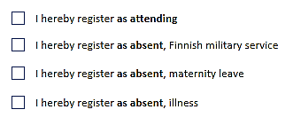

**B**

I hereby register **as** **absent**, Finnish military service

**I do not accept** my place in the programme referred to above.

I hereby enroll at Tampere University of Technology and agree to abide by the Campus rules and regulations governing the use of the University’s information systems ([www.tut.fi/en](http://www.tut.fi/en) > Current students)

Time and place: Signature: